**Business problem**

Create a model that tells us which add (from 10) should a company post on a social network.

**Explaining the model**

1. Import the dataset, which is in a csv format.
2. We use the columns of interest, which are the annual income and spending.
3. Since there is no package for the Thomson Sampling, we need to create it manually. We start by creating a vector that counts the number of times the add I received a reward 1 until round n, and another vector that does the same but for reward 0. Then, we create a loop that randomly sorts the adds to be shown, and finally we analyze the maximum of the random sorts.
4. After that, we plot the graph.

**Plotting the results**

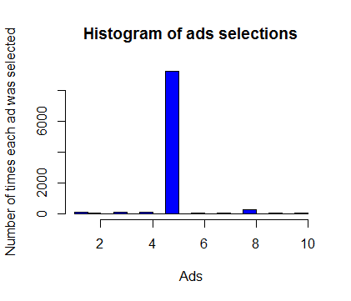

As we can see, the add with the most conversion rate is the add number 5.